

Product Catalog System

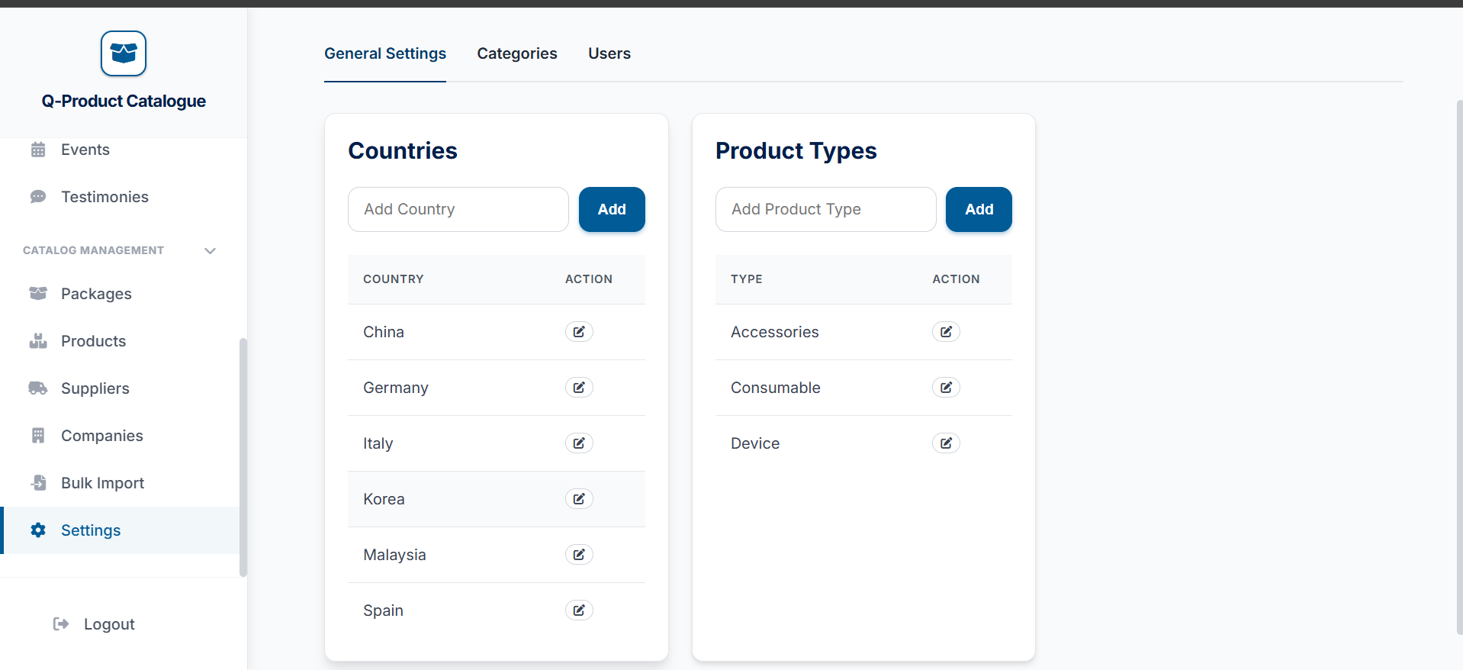
How to add a country
Go to the very bottom of the side bar to the Settings tab


Go to the categories tab here

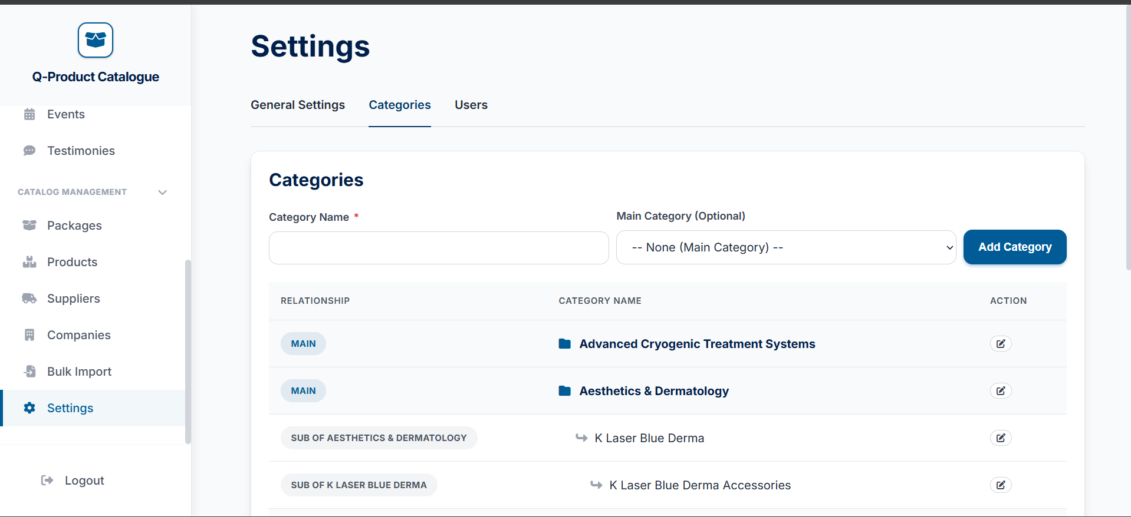


If you wish to create product categories in bulk please follow the steps below:
You can full the name of the category you like and choose a main category if this product category is a sub category
Enter the country you want here
Enter the country you want here
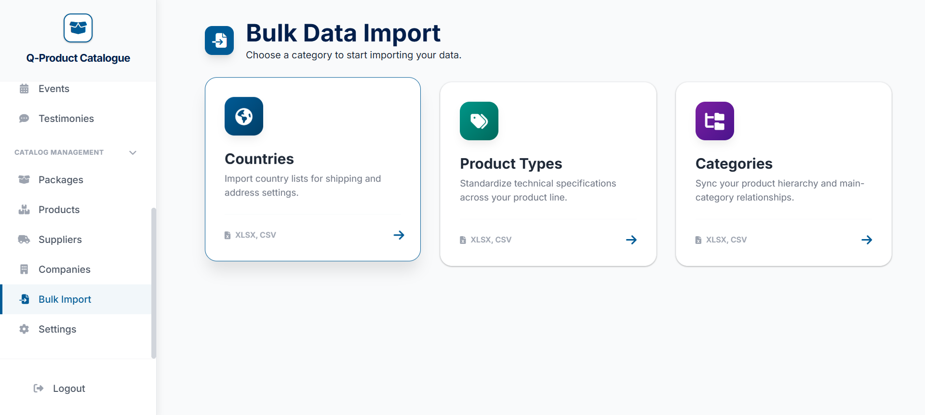
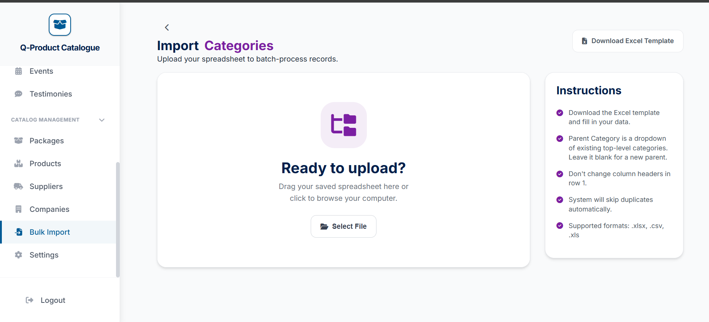


Then click on the product types option
Go to the Bulk import tab
Just download excel template and fill up the product catagories in that template
Then upload the filled template in here
Enter the country you want here
Enter the country you want here

